Imperial College Union Board of Trustees
30 Oct 2019
AGENDA ITEM NO.
TITLE | 2020+ Strategy Paper
AUTHOR | Abhijay Sood, Lloyd James and Jarlath O’Hara
EXECUTIVE SUMMARY | We outline the proposed process to developing our new strategy. This includes the overarching approach, the formation of three subgroups (Core strategy, College Funding and Consultation) and consultation timeline
PURPOSE | To update board and gain support for the next steps of strategy development.
DECISION/ACTION REQUIRED | Board support for the process: Approach; Subgroups; and Consultation.

Union 2020+ Strategy Paper

Background
The Union’s 2020+ strategy will play a key role in setting the direction for the whole organisation, for our Board and governance structures and for our staff and students. This comes at a critical time when resources are stretched and clarity of vision and prioritisation of projects and initiatives is required.
A strategy is formulated by considering:
- Where are we now?
- Where do we want to be (in 3 years)?
- What choices we will make on how to get there?

We have considered the strengths and weaknesses of both Our Plan 2013-16 and Our Strategy 2017-20 and our approach seeks to incorporate the best aspects of each as well as adding additional concepts.

Key considerations are to have:
- A Vision that assists with decision making
- SMART objectives which are clear how we will measure success
- A strategy that remains relevant throughout its lifecycle
- How we will know if we are ‘there’ – tangible aims

Our suggested approach
By the end of the new strategy, we want to have made a discontinuous leap in performance towards our vision.

As stated above, greater clarity and alignment of our direction and objectives with our performance management metrics is required. We propose building on our existing Balanced Scorecard and the work of Kaplan and Norton (1996) to determine metrics for where we are now and where we want to be by 2023. To achieve this, we propose:

- Our strategic objectives must be measured against a balanced scorecard composed of metrics that are *strategic* rather than *diagnostic*.
  - Diagnostic metrics – things we want to make sure we aren’t losing sight of operationally – should be tracked separately/alongside strategic metrics.
- Metrics should be a mix of lagging (outcome-) and leading (performance driving-) indicators
- Metrics should be selected in consultation with all relevant stakeholders to ensure they’re realistic, appropriate, and don’t create perverse incentives.
- Each of these strategic objectives must have year-to-year milestones so we know whether we are on track.
- The balanced scorecard should highlight the cause and effect relations between metrics, and therein provide a visual representation of our strategy.
- The balanced scorecard should be communicated to all staff, clearly and prominently. They should be able to identify their place in the strategy and formulate personal / team goals towards achieving the strategic objectives.

Adapting the Kaplan and Norton model for a commercial organisation, we identify the value chain by which ICU delivers an improved student experience. The exact headings here are just suggestions, but we propose adopting a strategy and scorecard in line with this format.

Student Experience
↑
Student Voice
↑
Student Development & Engagement
↑
Sustainable Organisation

It is clear how some of the useful measures from our current Balanced Scorecard would fit here whilst others would need new metrics. Examples that map across include:
- Sustainable Organisation
  - Financial performance
  - Staff retention, training and recognition
- Student Development & Engagement
  - Elections
  - Volunteer Training & Development
- Student Voice
  - Representation metrics
- Student Experience
  - CSP metrics
  - Enjoyment of venues

Values
These are important to guide our decision-making. Democracy & inclusivity are two of our four current values which are so core to what we do it would be difficult to envision us changing them. We recommend establishing four concise values following wider consultation focusing on the remaining values of Leadership and Partnership.

Consultation framework and timeline
Stakeholder consultation to ensure buy-in and support for our strategy will be essential. The Consultation Sub-Group will have oversight of this process, but the main categories are outlined here with brief summary of proposed steps.
- Board: Consultation began on the September strategy day and key checkpoints are outlined in the chart below with deeper involvement through the sub groups.
- Members: This is multi-layered and begins with existing data including Student Experience Survey, NSS, PRES/PTES. We will consult through formal and informal student meetings including Council, Governance & Identity, Rep meetings and will host focus groups for underrepresented student groups. We are also seeking feedback through individual consultation meetings with senior student volunteers (c.15 currently identified).
- Union Staff: Union staff have been consulted on: What they want from the strategy; What they would like it to include; and how they want to contribute. This produced some key considerations already fed in as well as commitments to gain further Input through team and directorate meetings and hosting focus groups on specified topics.
- College Staff: A spreadsheet of key College staff has been developed and used to shape the existing consultation opportunities. This results in a need to create additional opportunities and is being led by MD and President.
- External benchmarking: Analysis of sector and other relevant strategies through desk research, contacts and connections and potentially support of third-party organisation(s).
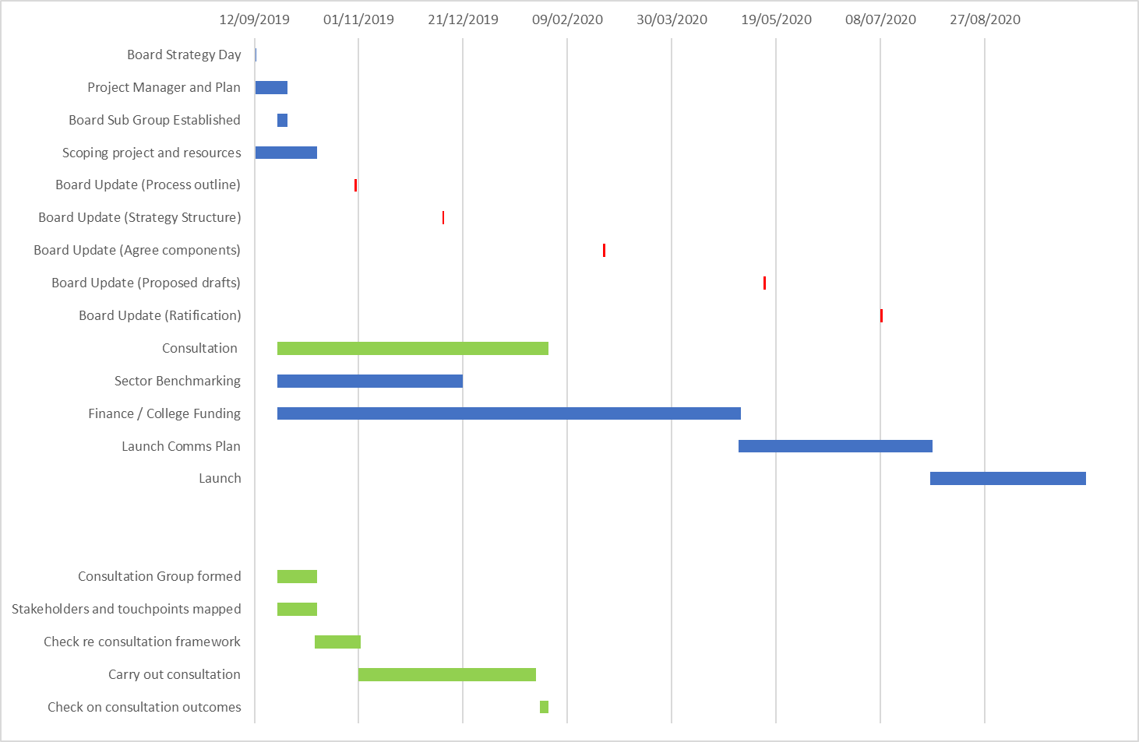

Sub Groups
Following the September strategy day, we called out for volunteers to form subgroups to oversee and assist in the different aspects of strategy development. Based on responses and other surrounding conversations, we propose the following subgroups and outline Terms of Reference.

Core Strategy subgroup – Monthly (until final document)
- Delegated ownership of process steps and timelines from Board.
- Delegated ownership of strategy formation from Board. Includes receiving consultation outputs, forming prioritisation which therefore feeds into funding group and setting first draft of strategy document.
  - MD
  - Pres
  - DPCS
  - HoSE
  - Council Chair
  - Chair of Board
  - F&R Chair
  - One student trustee (Jinpo)
College funding subgroup – Monthly (until end of Term 2)
- Advisory group for: Block grant negotiation (inc Staff salaries); capital funding agreement;
  - MD
  - Pres
  - DPFS
  - HoFR
  - HoCS
  - F&R Chair
  - One student trustee (Milia)
Consultation subgroup – meet in middle and end of consultation process
- Own the consultation plan, receive the data / feedback and approve the key messages that are extrapolated from that
- Ensure (internal) stakeholders input to metrics against strategic objectives
  - MD
  - Pres
  - DPE
  - HoSVC
  - Governance Chair
  - Two student trustees (Dan, Ansh)

Kaplan, R. and Norton, D. (1996). The Balanced Scorecard: Translating Strategy into Action. Harvard Business Press.

