HEALTH AND SAFETY COMMITTEE
The first meeting of the Health and Safety Committee for the 2018/19 session, was held on Monday 24th Sept 2018 in Meeting Room 6, Beit Quad at 11am.
Unconfirmed minutes
Present: | Claudia Caravello (CC) – Chair | Deputy President (Finance & Services)
 | Jessica Harrison (JH) | Events & Conferences Manager
 | Paul Gallagher (PG) | Social Enterprise Manager
 | Sangita Kerai (SK) | Safety Adviser and Departmental Administrator
 | Iain Pullar (IP) | Student Activities Manager
 | James Medler (JM) | Deputy President (Clubs & Societies)
 | Tim Flint (TF) | Assistant Building Manager, Estates Division
In Attendance: | Jomana Al Ahmad (JA) | Administration Support Officer
 | Adrian Mannall (AM) | Microsoft Cloud Tenancy Lead and Microsoft Supplier Relationship Manager
Apologies: | Martin Benson (MB) | Building Manager, Estates Division
 | Sean Fanning (SF) | Chief Fire Officer, Estates Division
 | Emelie Helsen (EH) | Student Development Manager
 | Paul Buckley (PB) | Head of Student Experience & Services
 | Surrinder Johal (SJ) | Director of Safety – Safety Department

Item 01 –Welcome and Chaires Business
- The Chair welcomed the Committee members and mentioned that the purpose of Committee is to consider all Health and Safety operations within the Union and to continuously review the measures taken for all major Union events and Clubs and Societies activities, the Chair encouraged all members of the Committee to participate and bring forward any issues of concern regarding health and safety.
- The Chair mentioned that an executive summary should be completed as a front page for all papers to streamline the format of papers submissions and this will be shared with the minutes of this meeting.

Item 02 - Declaration of Conflict of Interest
- None declared
Item 03 - Apologies
- Emelie Helsen, Paul Buckley, Sean Fanning, Surrinder Johal, Martin Benson

Item 04 – Events review
- IP gave a summary of the Health and Safety risk assessment for Freshers Fair, he mentioned that the same set up done last year has been approved and an assessment report on how we manage incidents is complete. He added that there are procedures in place to make sure incident seriousness is considered and the Union has liaised with University’s Fire Safety department to ensure that all scenarios are covered
- IP pointed out that MM is the Safety Officer on the day and he will be carrying out safety check walks throughout the day
- IP added that there are general risk assessments carried out for the Fair and specific assessments for certain clubs depending on the activities being undertaken. There is also a meeting for all staff to attend and IP will deliver a health and safety briefing so that everyone is aware of the actions to be taken in the case of an emergency, a staff pack will also be given to all staff
- IP also mentioned that radios will be provided with same set up as security
- JH gave a brief of the Health and safety considerations for the evening events and mentioned that the necessary risk assessment for each event has been carried out, additionally, First aid will be covered by trained First Aiders in the Bar
- JH added that Kristie Thacker, Jess Porritt and JH will be present to monitor the events on the night
Item 5 - CSP risk review
- The Chair presented the paper by mentioning the aim to identify the CSPs which the Committee would like to know more about in terms of risk assessments. She asked the Committee for ideas regarding the types and number of clubs who should present during Health and Safety meetings
- IP pointed out that this is not the updated list as scuba diving is a high risk club but is not on the list
- PG enquired about the purpose behind asking a specific club to present to find out about their assessments, as the Committee should be aware of their activities and assessments in advance
- MM responded that it may be better to consider auditing and choosing certain clubs from a random sample and carrying out an inspection rather than focus on high risk CSPs only
- IP added that medium risk clubs should also be a focus as high risk clubs are usually well regulated
- JM suggested asking high risk clubs with big events coming up to present
- PG also suggested looking at CSPs which have Health and Safety issues following inspections, SK agreed as this would allow the committee to suggest solutions to reduce the risk and ask the club to update the committee on the actions taken
- MM added that the committee should consider having an audit cycle that works beyond the committee, with the main updates to be fed back during the meetings, additionally to ask CSPs for presentations based on audit information
- JM added that an annual, more formal process via auditing is needed and IP suggested that the Committee can consider asking National Governing bodies to come and do audits in the long term
- The Chair concluded by asking JM to update the committee on an auditing process which will be used as a safety measurement system for CSPs for the coming year in the next meeting
Item 06 - Forward agenda
- The Chair presented the Forward Agenda to Committee members by explaining that it aims to capture all the main items to be considered by the Committee for the forthcoming year, and asked the Committee to let the Chair or JA know if they have any suggestions for changes to be made.
Item 07 – AOB
- A Microsoft Cloud Tenancy Lead and Microsoft Supplier Relationship Manager, Adrian Mannall, joined the Meeting to present a showcase of Teams 365 which will be used as a form of communication for the Committee for the AY 18/19. A summary of the showcase can be found below with an outline of the process going forward

How to access 365-Teams:
- Open your browser and type office.imperial.ac.uk in the address bar and log in using your credentials
- Office 365-Teams can be accessed by clicking on the Teams Icon on the main page
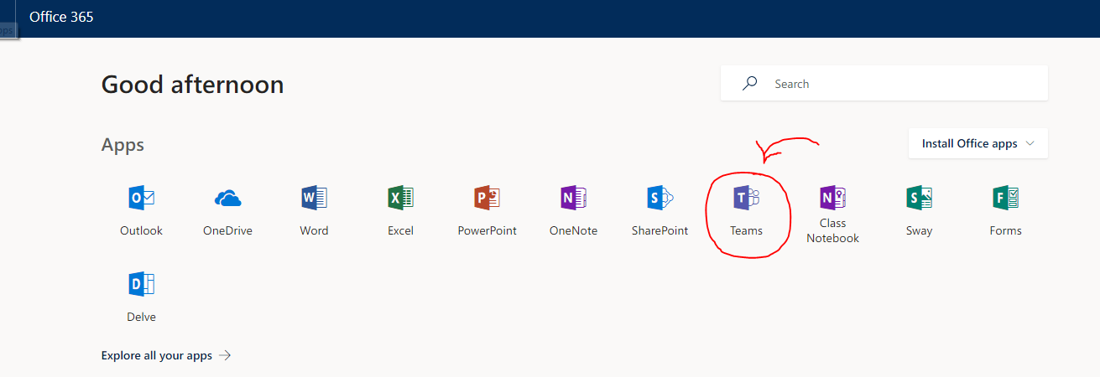
Downloading the application on your device
- To download the application your desktop/mobile/portable device for quick access, click on the personal avatar icon on the top right of the page and select ‘download desktop app’ or ‘download mobile app’

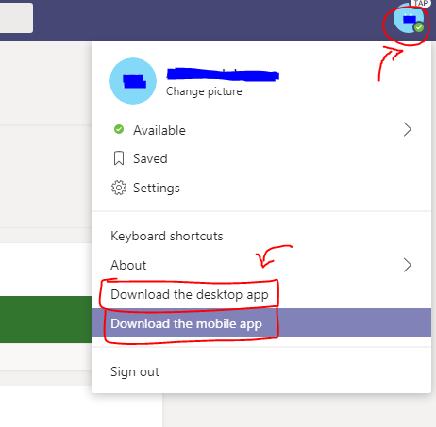
How to access the H&S Committee via Teams
- To access the Committee papers/updates click on the Teams tab on the left hand side of the page

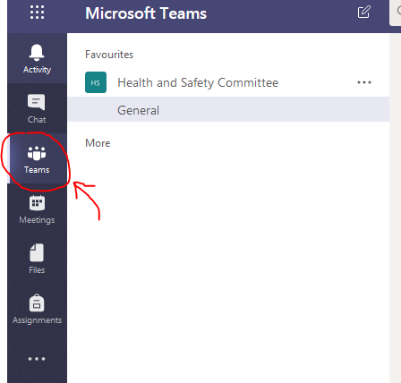
- You will then be able to view the H&S Committee general channel by selecting the H&S Committee under the favorites section
- On the conversation tab, updates will be posted such as meeting reminders, paper deadlines and meeting minutes once they are ready to circulate

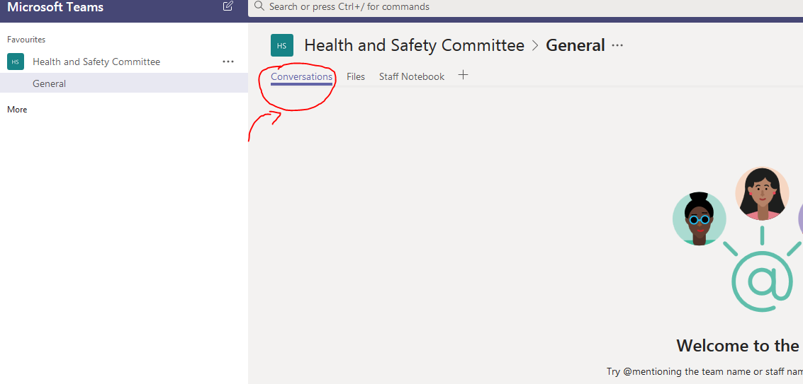
- In the files tab, you will be able to view committee papers once they are uploaded, you will also be able to view historic papers from previous meetings
Joining a meeting online via Teams
- If you wish to join the H&S committee meeting online via Teams, please inform the Admin Support Officer to ensure that a link is posted on the conversation tab

Process for future meetings:
- The Meeting Agenda, Action Tracker, Meeting Minutes and Forward Agenda will be uploaded on Teams in relevant folder within the files tab, the folder will be titled as the date of the upcoming Committee meeting, a message reminder will be sent on the general conversation tab to remind members that the meeting is approaching.
- Two weeks prior to the meeting a message reminder will be sent on the general conversation tab with the deadline for paper submission.
- The Papers must be submitted to the relevant meeting folder in the files tab, with an executive summary and a title corresponding to the Item number on the Agenda
- One week before the meeting, meeting members will be informed on the general conversation tab that papers have been submitted.
Please note: Anyone submitting papers past the deadline will be required to liaise directly with the Chair of the meeting regarding the late submission with a justification for the delay. Once agreed by the chair, it is the responsibility of the individual to inform members that a paper has been submitted late.
- The Committee meeting will be held and previous meeting minutes will be confirmed.
- The new meeting minutes will be sent to the Chair to approve within 3 working days.
- The new meeting minutes with the updated action tracker will be uploaded to the relevant folder on Teams no later than 7 working days following the meeting. A message will be sent to the general conversation tab to inform members that minutes have been uploaded.
*All specific deadline dates will be provided in the reminder.

Forward Agenda and Action Tracker:
In order to streamline the way we monitor and track the strategic steer of the organisation, the following documents are defined as outlined below:
Action Tracker: All action points discussed in a committee meeting will be transferred into an Action Tracker with the deadline for completion. Once the action is confirmed as completed in the next meeting it will be removed from the tracker.
Forward Agenda: This represents the annual work plan for each subcommittee, focusing on major topics scheduled for the year. The deadline for agreement of the forward agenda by each committee is the first subcommittee meeting of the year.

