Thinking of bringing some goodies to the fair?
We would welcome any free items that you want to distribute to students at the fair. If you’re thinking of bringing bags to distribute the goods in, we would ask that the bags are paper bags rather than plastic, and that they are able to be recycled after use or are reusable. This is part of ongoing work at the Union to measure our green impact. We would also ask that if you are bringing goods to the fair that, this packaging is able to be recycled as well. There are recycling facilities at the College that you will be able to use. Thank you for your cooperation.

Please complete the following details below and submit no later than Friday 15 September 2017. Submission details are overleaf.
Company name
Contact name
Contact number |  | Contact email
Address
PO number
(required)
Billing address
(required)
Finance contact
Contact number |  | Contact email

Which stand would you like?
This year’s Freshers’ Fair stalls are located in the Queen’s Tower Rooms on level 1 of the Sherfield Building and the Senior Common Room on level 2, and both levels of the Sherfield foyer.
All stands include 1m x 2m table and two chairs. Stands will be allocated nearer the time of the fair.
Agents please note that this fee is exclusive of your commission.
Please click or mark in the boxes below to make your selection for stalls, backboard and power.

☐ Premium+ Stand | £800 +VAT | 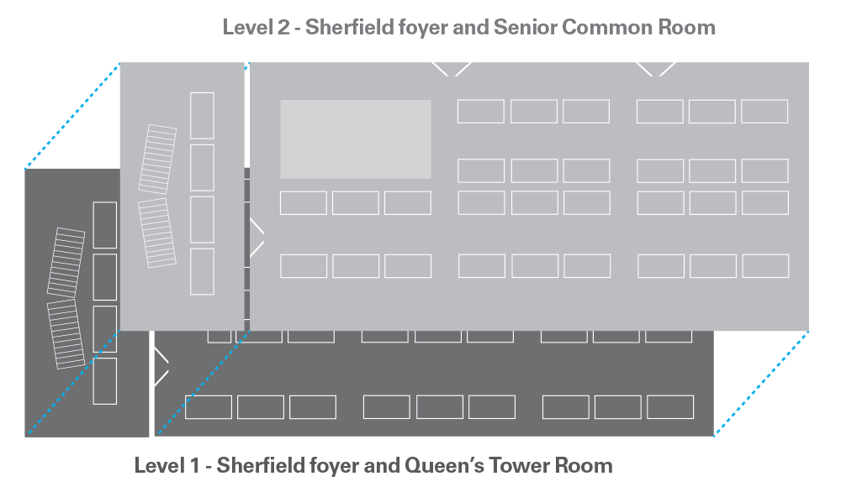  PLEASE NOTE: illustration above is not to scale, and is to show proximity of spaces only. Final layouts in rooms for the fair will change.
Located in the entrance of the Queen’s Tower Rooms on level 1 of the Sherfield Building and the Senior Common Room on level 2, and both levels of the foyer; giving you access to greater footfall of students. All stands include table approx. 1m x 2m and chairs.
☐ Premium Stand | £700 +VAT
Same as Premium + Stand, but among the first set that students come across as they enter the rooms. All stands include table approx. 1m x 2m and chairs.
☐ Standard Stand | £500 +VAT
Located in both rooms. All stands include table approx. 1m x 2m and chairs.
☐ Charity Stand | £350 +VAT
Same as Standard Stand, only available to registered charities. All stands include table approx. 1m x 2m and chairs.

Charity no.
(if applicable)
Need backboard? | ☐Yes  ☐No | Would you like power? | ☐Yes  ☐No | We will do our best to accommodate all requests for power; however, power cannot be guaranteed due to limited number of power points in the rooms.

Once we have received your booking for Freshers’ Fair 2017, we will send you an email confirming receipt of the form and acceptance of your booking, and then send you an invoice shortly afterwards. Further details will be sent out to you prior to the event.

Please read on for our Terms and Conditions and to sign the form.
Terms & Conditions

By signing this form I/We agree to abide by the following Terms & Conditions.
- NO TRADING WILL TAKE PLACE AT FRESHERS’ FAIR 2017. This includes signing students up to contracts, bank accounts or credit agreements of any kind.
- No distribution of alcohol and/or glass items will take place at the Fair.
- VAT applicable at standard rate to all prices. Cheques should be made payable to Imperial College Union (ICU).
- Confirmation of bookings is subject to ICU Regulations and procedures. confirmation email will be sent to you within three weeks from receipt of the booking form.
- Payment needs to be made in full before the Fair.
- Failure to pay in full will risk loss of the stall in question. Any stalls lost through non- payment will be invoiced as cancelled bookings (see cancellation charges).
- Cancellation Charges. The following cancellation rates apply for companies withdrawing within these periods:
  - Six (6) weeks prior to the Fair: 50%
  - Four (4) weeks prior to the Fair: 75%
  - Two (2) weeks prior to the Fair: 100%
- All measurements quoted are approximate.
- Persons attending the Fair will at all times: behave in responsible manner whilst on the Imperial College London (ICL) campus; not inconvenience either their organisers of the fair or any other exhibitors in any way; comply with the policies of Imperial College Union and Imperial College London (copies available on request). Failure to do so may result in removal from the Fair without prior notice or recompense.
- Exhibitors and their staff must conform to relevant legislation, regulations, British or EEC standards etc. as appropriate.
- Exhibitors are required to provide information on all displays including dimensions before Imperial College Union will accept the booking.
- All off-loading and loading of exhibits will normally be carried out by the exhibitor and not by staff of Imperial College Union or other organisers.
- Once exhibitors have off-loaded, vehicles should be removed from the ICL campus.
- There is no parking available on the day. Advance deliveries cannot be accepted.
- Displays involving equipment which moves shall not be left unsupervised.
- Exhibits will be constructed in locations allocated by the organisers and kept within the space parameters.
- Information and goods (including, but not limited to flyers, products etc.) may only be distributed from the appropriate stall location.
- Third party material may not be distributed.
- All electrical fittings, wiring and appliances shall be constructed and maintained in safe condition. Particular attention must be paid to the nature of temporary wiring and the need not to overload electrical sockets. Risk Assessments/RAMS reports are required and sign off lies with Imperial College Union.
- Loose packages must be removed once exhibition stands have been assembled.
- All exhibitors should note that ICL and ICU operate strict no-smoking policy within all buildings.
- Exhibitors exhibit entirely at their own risk. ICL and ICU are not liable for any losses or damage to persons or property which may occur. Insurance against such contingencies is recommended.
- Exhibitors must also indemnify ICL and ICU against all costs, claims and liabilities sustained by any persons or to any property as result of their actions.
- Failure to comply with any aspect of these Terms & Conditions/Code of Practice will result in the removal of permission to exhibit. Neither ICL or ICU will refund any payments under these circumstances.
- All details are correct at time of going to print. However, they may be subject to change without notification.

Your name
Your signature
Date
...or post it to
Freshers’ Fair 2017, Imperial College Union, Beit Quadrangle, Prince Consort Road, SW7 2BB

Email this form to unioncoms@imperial.ac.uk

