How to fill in a risk assessment
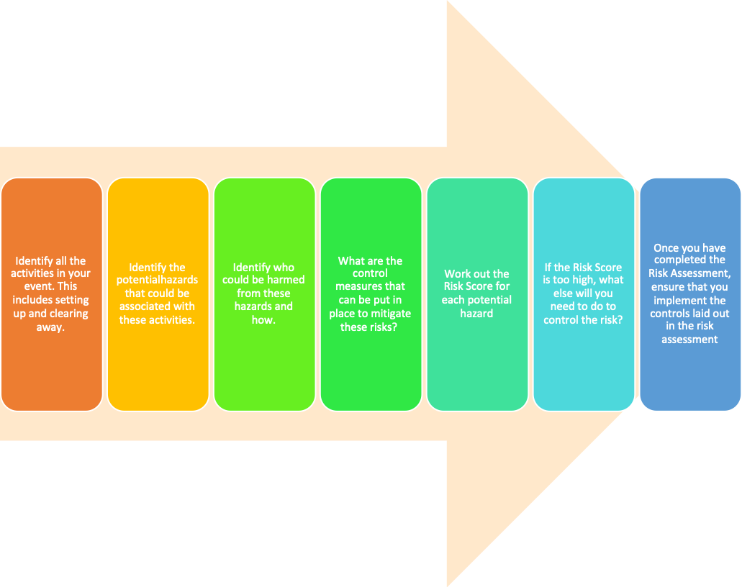

ACTIVITY REGISTRATION
1. PERSON CARRYING OUT ASSESSMENT
Name of Society | Date of Event | Name of Event | Assessed By [full name and committee] role of member responsible for event]

2. DESCRIPTION OF ACTIVITY (hourly breakdown, from start to finish, include accessing storage, transportation if relevant, content of event, sponsorship)

3. LOCATION and SIZE (if in external venue feel free to attach their risk assessment too)
Campus | Building | Room | Venue name (if not on campus) | Number of attendees

4. How often is the activity being carried out?
Once a day Once a week Once a month Every 6 months Annually
Other – give details:

Hazards summary
A hazard is defined as something with the potential to cause harm whilst harm is usually used in the context of pain and suffering to individuals it can also be used to describe the negative effects of a particular risk or objective being achieved such as an inability to achieve income or bad publicity.
Identify potential hazards consider all the activities within the event here is a list of potential hazards that may apply to your event. Select yes to those that apply.
Please be aware that this is not an exhaustive list and there will be hazards identified to your event that are not listed.
5. HAZARD SUMMARY (please mark ‘Yes’ or ‘No’. Any marked ‘Yes’ must be described in section 7)
Accessibility |  | Mechanical
Manual Handling |  | Hazardous Substances
Electrical |  | Noise
Working at height |  | Extreme temperature
Alcohol consumption |  | Controversial content
Confined space |  | Crowd control
Fire hazards |  | Fireworks
Food provision |  | Heating & ventilation
Hot water/liquids |  | Inflatables
Lasers |  | Layout & traffic routes
Lighting levels |  | Lighting systems
Marquees |  | Other temporary structures
Pulled muscles |  | Pyrotechnics
Sanitation |  | Speaker/Panellist event
Seating arrangements |  | Use of portable tools/equipment
Vehicles, driving |  | Violence to attendees or staff
Welfare |  | Work with animals
Falling objects |  | Pressure/steam
Trip hazards |  | Other – Please specify
Lone Working Permitted? | Yes No | Permit-to-Work required for planned maintenance? | Yes No N/A

6. Who might be harmed and how? (Please mark ‘Yes’ or ‘No’.)
Identify people at your event who may be at risk from potential hazards here is a list of potential people that may apply to your event.
Students |  | Cleaners, engineers etc
Staff |  | Children / under 18’s
Contractors |  | Participants
Those with accessibility needs |  | Spectators
The public (non-ICU members) |  | Other

Risk Rating
Risk is the combined assessment of the likelihood and severity for any given hazard, so therefore there are two elements that you will need to look at when assessing the level of risk:
Risk Severity: (the severity of any resulting injury or ill−health)
MINOR: Superficial injuries - cuts, bruises, mild skin irritation, mild aches, and pains − requiring first aid only. Minor property damage.
SERIOUS: More serious injuries or ill-health, requiring time off work or study or a hospital visit, e.g. burns, sprains, strains and short-term musculoskeletal disorders, cuts requiring stitches, back injuries, fractures to fingers or toes. More serious property damage.
MAJOR: Broken limbs, amputations, long-term health problems resulting from work, or acute illness requiring medical treatment, loss of consciousness, serious electric shock, loss of sight. Major property damage.
FATAL: Injury or ill-health which leads to death either at the time or soon after the incident, or eventually, as in the case of certain occupational diseases, such as asbestos-related cancers.
Risk Probability: (the likelihood of the hazard causing harm).
VERY UNLIKELY: Good control measures are in place. Controls do not rely on a person using them (i.e. personal compliance). Controls are very unlikely to break down. People are very rarely in this area or very rarely engage in this activity.
UNLIKELY: Reasonable control measures are in place, but they do rely on a person using them (some room for human error). Controls unlikely to breakdown. People are not often in this area / do not often engage in this activity / this situation is unlikely.
POSSIBLE: Inadequate controls are in place, or likely to breakdown if not maintained. Controls rely on personal compliance. People are sometimes in this area or sometimes engage in this activity / this situation sometimes arises.
LIKELY: Poor or no controls in place. Heavy reliance on personal compliance (lots of room for human error). People are often in this area / engage in this activity on a regular basis / this situation often arises.
Use this matrix to find your risk score for each identified hazard:
 |  | RISK SEVERITY
 |  | MINOR | SERIOUS | MAJOR | FATAL
RISK PROBABILITY | VERY UNLIKELY | 1 | 2 | 3 | 4
 | UNLIKELY | 2 | 4 | 6 | 8
 | POSSIBLE | 3 | 6 | 9 | 12
 | LIKELY | 4 | 8 | 12 | 16

The below is a template, you are expected to add and edit this, so the activity, hazards and controls are ONLY relevant to the event description in section 2. Unedited risk assessments will be rejected.

7. Brief description of the activity/procedure (in steps) | Potential hazard | Existing and additional controls required | L | S | Risk ratting  Likeliness x Severity = RR
In person events
This is an example please amend as appropriate  Gathering of people indoors | Contracting COVID 19 | Reassure those wanting to wear a mask. Keep the room well ventilated. Anyone with symptoms of COVID will be encouraged not to attend. Provide hand sanitising stations at entrances and exits. | 1 | 3 | 3
This is an example please amend as appropriate  Setting up tables | Injury form incorrect manual handling | Asses the weight and type of load being moved, review the ability of the individual person carrying out the task, have two committee members move any awkward or heavy load. Assess the space surrounding the tables being moved. | 1 | 2 | 2
This is an example please amend as appropriate  Food Provision | Food poisoning, allergic reactions, cross contamination | Food will be pre-packaged with no additional storage requirements. Allergens will be clearly displayed, and food will be kept separate to prevent cross contamination. Food will not be left uncovered for long periods of time. | 1 | 3 | 3
This is an example please amend as appropriate  Electrical | Electrical shocks or burns from faulty electrical equipment. Electrical faults can also lead to fires. | Only PAT tested equipment will be used. Any defective equipment taken out of use safely and promptly replaced. Do visual checks of wires, keep electricals away from liquids. | 1 | 3 | 3
This is an example please amend as appropriate  Trainings, matches, sporting activity | Injuries | A Union approved qualified instructor will be present. There will be a full warm up before activities take place and a full cool down after activities.  Suitable equipment and clothing worn and any attendees not appropriately dressed or warmed up will not participate.  Committee/instructor will ensure novice attendees are appropriately briefed. | 1 | 3 | 3
Online events
This is an example please amend as appropriate  Use of the chat function/ Q&A format | Reputational damage for ICU and CSP if inappropriate messages or images are posted/shared. | Assign a chat moderator, with ability to mute chat or remove offensive attendees.  Circulate house rules and/or the College’s Code of Conduct to attendees before event takes place.  Any inappropriate conduct will result in the participant’s removal and will be reported to the Union. | 2 | 4 | 8
This is an example please amend as appropriate  Event accessible to under 18’s. | Safeguarding of vulnerable attendees breached. | Gain parental consent of all under 18s attending prior to event, adult to have access to event link too.  If parental consent is not received, then under 18 attendees to be barred from activity | 1 | 3 | 3
This is an example please amend as appropriate  Screen Fatigue | Eye strain from looking at computer screen for too long | Anyone presenting online to keep maximum event time to 2 hours. Where event exceeds 1 hour, 10-minute break to be inserted at midpoint. | 1 | 2 | 2
Other Hazards and controls required – insert here

8. Are extra precautions needed? If no, please tick box and move onto next section
If yes, please describe | Who has been asked to do this? | By what date?
9. EMERGENCY ACTIONS
Name of First Aiders Present:
If no first aider is present, what action will be taken if First Aid is required?

10. Monitor and review
Controls should be monitored: daily weekly monthly 6 monthly annually other
I will review this risk assessment at least every 6 months every 12 months
Immediately in the event of process / location change or incident or accident

11. Specialist training record – use this section to record the names and date of any persons with specialist training which are required to attend your event.
Name | Qualification required | Date of qualification expiration

Attach any external supplier and venue risk assessments below.

